13.STOCK MANAGEMENT SYSTEM

CLASS DIAGRAM:

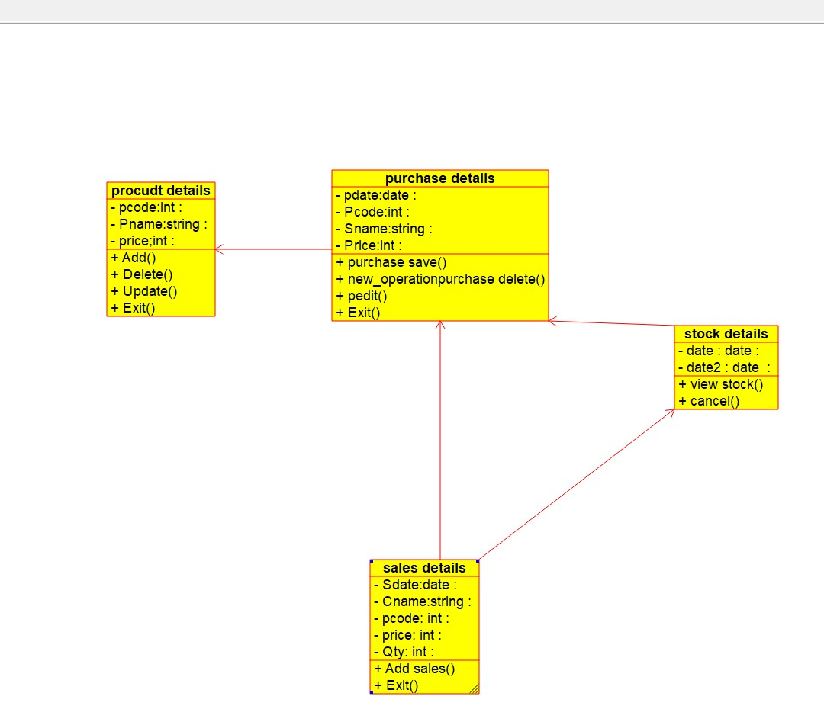

SEQUENCE DIAGRAM:

COMPONENT DIAGRAM:

14.E-COMMERCE SYSTEM:

CLASS DIAGRAM:

SEQUENCE DIAGRAM:

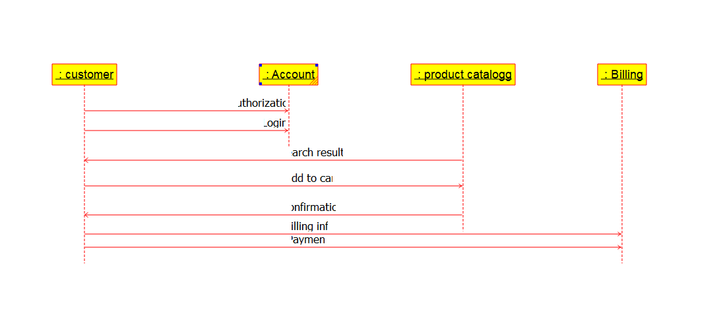

COMPONENT DIAGRAM:

15.BLOOD BANK REGISTRATION

CLASS DIAGRAM:

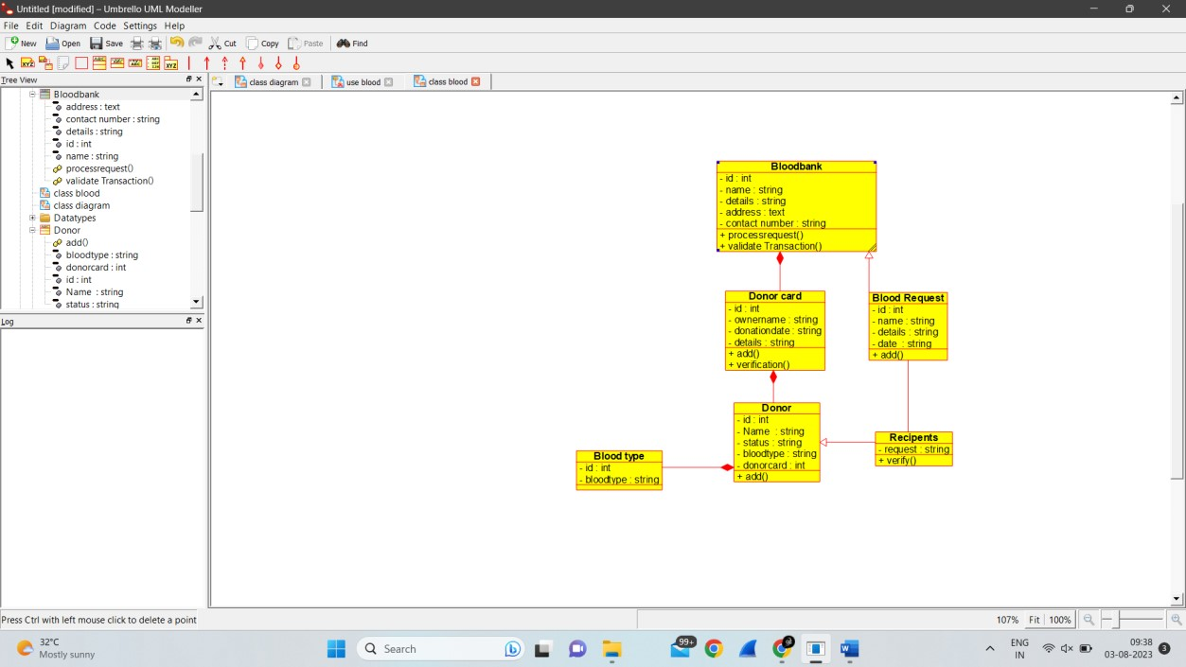

SEQUENCE DIAGRAM:

COMPOENENT DIAGRAM:

16.ONLINE INTERNSHIP REGISTRATION:

CLASS DIAGRAM:

SEQUENCE DIAGRAM:

COMPONENT DIAGRAM: